3GPP TSG-RAN WG1 Meeting #98 Tdoc R1-19xxxxx

Prague, CZ, Aug 26th –30th, 2019

Agenda Item: x.x.x

Source: Ericsson

Title: Meeting report from informal F2F meeting on indoor industrial channel model

Document for: Information

# 1 Introduction

An informal F2F meeting was conducted on July 1-2 in Berlin, Germany. The purpose of this meeting was to facilitate technical discussions and consensus building among channel model experts to support the SI on Indoor Industrial channel modeling. This tdoc contains a meeting report summarizing the discussions and views that were exchanged during the meeting.

# 2 Participation

The following participants attended the meeting:

1. **Raschkowski, Leszek, Fraunhofer HHI**
2. **Henrik Asplund, Ericsson**
3. **Rodriguez Larrad, Ignacio, Nokia**
4. **Koshiro Kitao, DOCOMO**
5. **Prasanth Karunakaran, Fraunhofer IIS**
6. **Schmieder, Mathis, Fraunhofer HHI**
7. **Jaeckel, Stephan, Fraunhiofer HHI**
8. **Tommi Jamsa, Huawei**
9. **Landmann, Markus, Fraunhofer IIS**
10. **Müller, Robert, Fraunhofer IIS**
11. **Guo Bolun, Huawei**

Remote participants:

1. **Piyush Gupta, Qualcomm**
2. **Raffaele D'Errico, CEA-LETI**
3. **Jianwu Dou, ZTE**
4. **Georg Wannemacher, Deutsche Telekom**
5. **Rakesh Tamrakar, Vivo**
6. **Xiaodong Sun, Vivo**
7. **Jian Luo, Huawei**

# 3 Company input

Company input is available at <ftp://ftp.3gpp.org/Email_Discussions/RAN1/RAN1_IIChM_July19/Docs/>

# 4 Technical discussions

## 4.1 New measurements

Fraunhofer IIS presented the contribution [R1-XXXX-Single-band.docx](ftp://ftp.3gpp.org/Email_Discussions/RAN1/RAN1_IIChM_July19/Docs/R1-XXXX-Single-band.docx) containing new measurements in a high clutter density environment.

* Comments on how to take into account the very large relative bandwidth in the path loss analysis
* What percentage of floor area is covered by clutter? 3D scanner data available that can be processed
* Discussion on how this clutter density compares with some other available measurements
* Raw path loss data for 6 GHz has been shared
* 30 GHz may be added before RAN1#98

Fraunhofer HHI presented the contribution [2019-07-01 Industrial Indoor Measurements.pptx](ftp://ftp.3gpp.org/Email_Discussions/RAN1/RAN1_IIChM_July19/Docs/2019-07-01%20Industrial%20Indoor%20Measurements.pptx) containing new measurements in high clutter density environments.

* Can share path loss data points (5500 points in total)
* Angular spread is based on specular only (100 paths)
* Question on ratio between power of specular components and dense multipath. Has been analyzed…
* Which sub-scenario? 2 and 4: high clutter density, 3 m clutter height, BS height 2-8 m
* Fraunhofer have added their path loss and LSP results (possibly split into sub-scenarios) into [R1-19xxxxx Path loss model parameters_v3_CEA_HHI.xlsx](ftp://ftp.3gpp.org/Email_Discussions/RAN1/RAN1_IIChM_July19/Docs/R1-19xxxxx%20Path%20loss%20model%20parameters_v3_CEA_HHI.xlsx), raw path loss data will be shared

Fraunhofer HHI presented additional measurements in a circular hall at 28 GHz in [2019-07-02_Fraunhofer_HHI_Directional Wideband Channel Measurements at 28GHz.pptx](ftp://ftp.3gpp.org/Email_Discussions/RAN1/RAN1_IIChM_July19/Docs/2019-07-02_Fraunhofer_HHI_Directional%20Wideband%20Channel%20Measurements%20at%2028GHz.pptx).

* Results on path loss; parameters available and raw data can be shared
* NLOS path loss is close to or even lower than free space, reason possibly due to calibration/antenna patterns?
* Blockage loss small due to multipath
* Delay spread parameters and hall volume can be compared to volume-dependent proposal
* ASD/ASD parameters will go into the excel sheet

## 4.2 Scenario description

Discussion on threshold between low and high clutter density:

* Nokia has estimated the clutter densities as above 50% for all high clutter density scenarios
* Fraunhofer IIS has calculated clutter density to 35% for a high clutter scenario
* Ask CMCC about clutter density in their low clutter scenario
* DOCOMO has estimated 29% in their scenario which is in between low and high clutter density, Huawei: DOCOMO path loss seems different compared to high density results

Outcome: High clutter density is above [35%] and low clutter density is below [35%]. Classify DOCOMO results as low clutter density

Discussion on clutter height:

* Ericsson proposes 1-10 m, Nokia proposes an open range with h_clutter lower than ceiling height
* Nokia: open scenarios have higher ceiling height than high clutter density scenarios, suggest to couple ceiling height range with clutter density
* Nokia has compiled a complete scenario description table in [R1-xxxxxxxx_scenario_parametrization_nokia_v2.docx](ftp://ftp.3gpp.org/Email_Discussions/RAN1/RAN1_IIChM_July19/Docs/R1-xxxxxxxx_scenario_parametrization_nokia_v2.docx).
  + Discussion outcome: Use this scenario description with the following changes:
    - Change the ceiling height for sub-scenario 5 to [5-25] m
    - “Clutter height” -> “Effective clutter height”
    - Add “typical clutter size”: Big = 10 m, Small to medium = 2 m

## 4.3 Path loss

Huawei presented a first attempt at producing merged path loss models in [IIot Path Loss measured data expressions and curves_v1.3.xlsx](ftp://ftp.3gpp.org/Email_Discussions/RAN1/RAN1_IIChM_July19/Docs/IIot%20Path%20Loss%20measured%20data%20expressions%20and%20curves_v1.3.xlsx) based on (a sub-set of) the available raw path loss data. The following improvements were discussed:

* Classify/re-classify sub-scenario association
* Include missing raw data, e.g. Huawei/CEA-LETI/Fraunhofer (AP: Huawei)
* Include random raw data generated from contributed path loss parameters (AP: Huawei, Nokia)
  + How many data points? If not specified, check the reference if there is some information. Otherwise, handle later.
* How to apply weights to the data from different sources (low vs high number of samples in different data sets)
  + No additional weighting as a starting point. Revisit later.

Nokia provided random path loss data based on the path loss parameters available in the v3 email discussion summary. Huawei updated the merge document to v1.4 to include “all LOS” and “all NLOS” cases. Huawei provided further updates using CMCC, CEA-LETI, and Fraunhofer HHI raw data, and also using the random raw data provided by Nokia. Available as [Nokia_data_combine_for_all_subscenarios_sc1_2_with_formulas_v1.xlsx](ftp://ftp.3gpp.org/Email_Discussions/RAN1/RAN1_IIChM_July19/Docs/Nokia_data_combine_for_all_subscenarios_sc1_2_with_formulas_v1.xlsx) and [Nokia_data_combine_for_all_subscenarios_sc3_4_with_formulas_v1.xlsx](ftp://ftp.3gpp.org/Email_Discussions/RAN1/RAN1_IIChM_July19/Docs/Nokia_data_combine_for_all_subscenarios_sc3_4_with_formulas_v1.xlsx) for the random data and [IIot Path Loss measured data expressions and curves_v1.5 CMCC CEA HHI.xlsx](ftp://ftp.3gpp.org/Email_Discussions/RAN1/RAN1_IIChM_July19/Docs/IIot%20Path%20Loss%20measured%20data%20expressions%20and%20curves_v1.5%20CMCC%20CEA%20HHI.xlsx) for the raw data.

* What is shown in the figures? One curve is from raw data, the other from random raw data generated by Nokia
* Outcome of discussion: Huawei will provide a further update by merging the raw data and random data together by Thursday, also merge all LOS data into a single path loss model
  + Other companies can review the proposal until Friday, which is the deadline for the merge proposals to [97-NR-10]

Discussion on embedded devices:

* Qualcomm may do new measurements on other aspects than path loss, trying to complete before August meeting
* Wait with further discussion until August, Qualcomm encouraged to provide a complete model proposal

## 4.4 LOS probability

Discussion on LOS probability:

* Agreement from Reno: ${Pr}_{LOS,subsce}\left[d_{2D}\right]=\left\{\begin{aligned}p_{subsce},d_{2D}≤d_{subsce}\left[m\right] \\ e^{\left(-\frac{d_{2D}-d_{subsce}}{k_{subsce}}\right)}⋅p_{subsce},d_{2D}>d_{subsce}\left[m\right]\end{aligned}\right.$
* Two proposals: empirical or analytical as captured in ZTEs contribution [ZTE_LOS probability.docx](ftp://ftp.3gpp.org/Email_Discussions/RAN1/RAN1_IIChM_July19/Docs/ZTE_LOS%20probability.docx).

Discussion outcome: As a starting point for calibration, use proposal 2 from ZTE:

***Proposal 2***: For analytical LOS probability model, use following formula to calculate $k_{subsce}$, where r is the effective clutter density after removing the clutters no higher than UE, $d_{clutter}$ represents the clutter size, {$h_{c}$, $h_{BS}$, $h_{MS}$} are the heights of clutter, base station and terminal, respectively.

$$k_{subsce}=\left\{\begin{matrix}-\frac{d_{clutter}}{\ln\left(1-r\right)} & BS embedded \\ -\frac{d_{clutter}}{\ln\left(1-r\right)}∙\frac{h_{BS}-h_{UT}}{h_{c}-h_{UT}} & BS elevated\end{matrix}\right.$$

* $p_{subsce}$ and $d_{subsce}$ are FFS.

Discussion outcome: use the following values as starting point and for calibration:

* For elevated and high clutter density: d_subsce=[1], p_subsce=[0.6]
* For all other cases, d_subsce=[0], p_subsce=[1]

Discussion on LOS autocorrelation:

* Two proposals: 18/20 m or equal to $d_{clutter}$
* Nokia: Related to $d_{clutter}$, to make it different for different sub-scenarios
* Huawei: 18/20 m is seen as too long, perhaps use a smaller distance such as 10/20?
* Ericsson: good to have short correlation distance to get better statistical significance of simulation of a limited area
* Fraunhofer HHI: prefer single number
* Outcome of discussion: Use [10 m] for calibration

Discussion on inter-site correlation of LOS state (two BS to one UE)

* Companies are encouraged to provide data on the correlation
* If no data, consider leaving as is (uncorrelated)

## 4.5 Fast fading modelling

Discussion on how to merge LSP proposals

* Ericsson provided an updated plot of DS vs hall volume to include new results that were not part of the tdoc in Reno in [Delay spread vs hall volume_v3.pptx](ftp://ftp.3gpp.org/Email_Discussions/RAN1/RAN1_IIChM_July19/Docs/Delay%20spread%20vs%20hall%20volume_v3.pptx). Discussion:
  + “Raw data” available in the ppt and in R1-1905202. Further possible analysis to look at reverberation theory using surface area and volume [Fraunhofer IIS, this week]
* Huawei provided updated LSP proposals in [R1-19xxxxx LSP parameter proposals_v3_CEA_HW2.xlsx](ftp://ftp.3gpp.org/Email_Discussions/RAN1/RAN1_IIChM_July19/Docs/R1-19xxxxx%20LSP%20parameter%20proposals_v3_CEA_HW2.xlsx)
* Fraunhofer provided updated LSP proposals in [R1-19xxxxx LSP parameter proposals_v3_CEA_HW_HHI.xlsx](ftp://ftp.3gpp.org/Email_Discussions/RAN1/RAN1_IIChM_July19/Docs/R1-19xxxxx%20LSP%20parameter%20proposals_v3_CEA_HW_HHI.xlsx)
* These two inputs have been combined in [R1-19xxxxx LSP parameter proposals_v3_CEA_HW_HHI2.xlsx](ftp://ftp.3gpp.org/Email_Discussions/RAN1/RAN1_IIChM_July19/Docs/R1-19xxxxx%20LSP%20parameter%20proposals_v3_CEA_HW_HHI2.xlsx)
* Possible merging principles:
  + Plot all the data for each parameter, propose merged parameter values (if possible just an average, otherwise some functions)
  + Fraunhofer will propose a set of merged parameters by Thursday EOB

Discussion on dense multipath

* The experience from Fraunhofer IIS is that up to 80-90% of indoor power is captured in the dense multipath, more dense multipath in sub-6 GHz than at mmw
* Different views on the spatial properties of the DMC, white or not?
* How to capture dense multipath? Proposals:
  1. Optional model: Consider if 38.901 sec 7.6.2 approach can be used to emulate DMC using more rays
  2. Optional model: Colored noise process to model the transfer function (of frequency and tx/rx antenna elements), using frequency correlation function and angular correlation functions. Few analysis available on the correlation properties of the DMC in f and antenna dimensions
  3. Baseline model: Change (increase) the number of clusters and rays in the baseline model
  4. Room electromagnetics for DMC (Univ of Ghent): 30% of the power in the DMC
  5. Do nothing
* Conclusion: encourage companies to analyze DMC in their measurements and if necessary propose models and parameterizations until Prague. If no such proposals, don’t do anything.

## 4.6 Additional modelling components

Presentation on new measurements and modeling of additional delay by Fraunhofer IIS and Huawei in [Berlin_Meeting_NLOS_Relative_Delay_Results_v2.pptx](ftp://ftp.3gpp.org/Email_Discussions/RAN1/RAN1_IIChM_July19/Docs/Berlin_Meeting_NLOS_Relative_Delay_Results_v2.pptx). Discussion:

* New results show clear dependence on distance
* Lower bound at shorter distances may be due to obstructed LOS (diffraction). Suggestion to use lower bound for  that is larger than 0
* Can the distance trend be extrapolated beyond 40 m? Will give >700 ns DS for 280 m…
* Perhaps fitting against log(distance) instead?
* Select strongest or first peak? The first peak within -5 dB of the strongest one
* 6 and 60 GHz data may be available later, also analysis with different thresholds

Discussion on absolute delay modeling

* How to select from the different proposals (including the new one from H/IIS)?
* Outcome: Encourage companies to share data: (f,d,) samples and report the used detection threshold
  + Analyze based on merging of data from multiple sources [Huawei volunteers]
  + Further discussion on upper bound and cross-correlations over email

Discussion on spatial consistency

* Qualcomm will provide more analysis and proposal on the update distance of the UT in Procedure A

Discussion on blockage

* Encourage companies to make specific proposals on typical blocker densities sizes, revisit in Prague
* Discussion outcome: Add the following recommended blocker for industrial scenarios:
  + AGV: 3x1.5 m (WxH), up to 30 km/h
  + Industrial robot: 2x0.2 m (WxH), up to 3 m/s
  + Humans (as for indoor/outdoor)

Discussion on measurements

* Proposal from Nokia: Similar to what was done for Urban Macro, urban Micro, Indoor and O2I, the final TR should contain the list of measurement contributions to the model from the different sources.
* Discussion outcome: Include the following sentence in sec 6.3: “The Industrial channel model was developed using measurements contributed by NNN, MMM, OOO, and by considering information in the literature. An overview list of all such contributions and sources is available in tdoc R1-19xxxxx.”

Discussion on dual mobility

* Huawei presented a modeling proposal in [ModDualMobility_Huawei_Draft.docx](ftp://ftp.3gpp.org/Email_Discussions/RAN1/RAN1_IIChM_July19/Docs/ModDualMobility_Huawei_Draft.docx).
* Discussion outcome: Use the Huawei modeling proposal below (which appears to be aligned with the Ericsson proposal)
* ***Proposal: The impact of scatterer movement should be modeled as***

$v_{n,m}=\frac{{\hat{r}}_{rx,n,m}^{T}∙{\overline{v}}_{rx}+{\hat{r}}_{tx,n,m}^{T}∙{\overline{v}}_{tx}+2{α_{n,m}D}_{n,m}}{λ_{0}}$

***where $D_{n,m}$* is a random variable with uniform distribution from $-v_{scatt}$ to $v_{scatt}$, $α_{n,m}$ is a binomial random variable with parameter n=1 (i.e. Bernoulli trial), parameter p is FFS, and $v_{scatt}$ is the maximum speed of the clutter.**

## 4.7 Channel model calibration

* Table 7.8-2: Simulation assumptions for large scale calibration for the indoor industrial scenario

|  |  |
| --- | --- |
| Parameter | Values |
| Scenario | Indoor industrial – sub-scenarios 1-4 |
| Room size | 100x100 m |
| Room height | 10 m |
| Sectorization | None |
| BS antenna configurations | 1 element (vertically polarized), Isotropic antenna gain pattern |
| UT antenna configurations | 1 element (vertically polarized), Isotropic antenna gain pattern |
| Handover margin (for calibration) | 0dB |
| BS deployment | Rectangular grid with ISD = 20 m, FFS on exact grid and number  BS height = [1.5] m or 8 m |
| UT distribution | uniform dropping for indoor with minimum distance ([2D or 3D]) of [1] m  UT height = 1.5 m |
| UT attachment | Based on pathloss |

* Outcome of discussion: Use the following simulation assumptions for calibration of the indoor industrial scenario:
  + Hall sizes: sub-scenario 1: 60x120 m, 2: 300x150 m, 300x150 m, 4: 60x120 m
  + Use a minimum 2D dropping distance of 1 m
  + BS height is 1.5 m for the clutter-embedded scenarios
  + BS tx power: 30 dBm
  + BS deployment: in rectangular grid with 20 m spacing and 10 m from the walls for the small halls, and in rectangular grid with 50 m spacing and 25 m from the walls for the big halls
  + ~~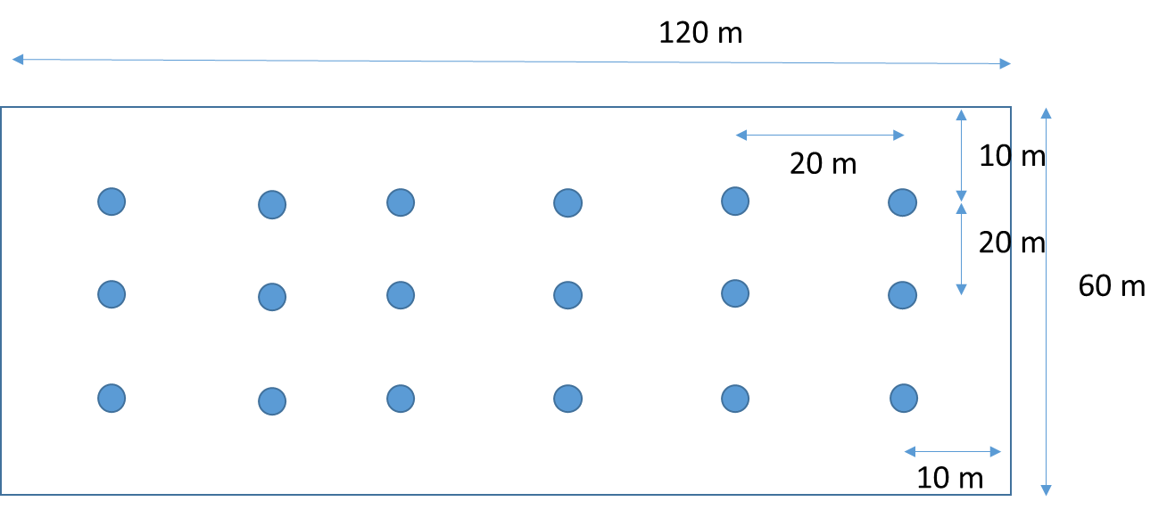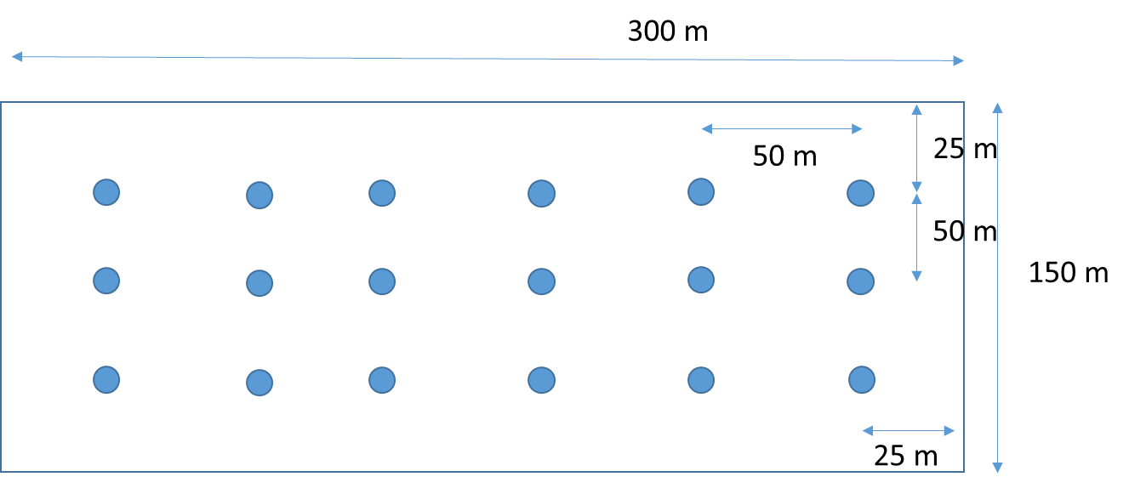~~
  + UT noise figure: 9 dB
  + Carrier frequency: 3.5 GHz, 28 GHz
  + Bandwidth: 100 MHz
* Outcome of discussion: The following metrics are proposed for the channel model calibration:
  + 1) Coupling loss – serving cell
  + 2) Geometry with and without noise
  + 3) CDF of delay and angle spread (ASD, ZSD, ASA, ZSA) according to definition in Annex A.1 of TR 38.901
  + 4) CDF of first path excess delay for serving cell

Discussion outcome: Use the following parameters for calibration:

|  |  |  |
| --- | --- | --- |
|  | Low clutter density | High clutter density |
| Clutter density: r | 20% | 60% |
| Clutter height: $h_{c}$ | 2 m | 6 m |
| Clutter size: $d_{clutter}$ | 10 m | 2 m |

# 5 Summary

The participants in the meeting discussed a number of topics related to the indoor industrial channel model as detailed in section 4. Significant work was spent on collecting and combining data and proposals from different companies, where the data available in the email discussion [97-NR-10] was complemented with additional new measurement data from different sources. Progress was made on merging the data sets and deriving fitting curves for path loss and proposals for LSP parameter tables, however this work was still ongoing at the close of the meeting.

All contribution documents to the meeting are available at <ftp://ftp.3gpp.org/Email_Discussions/RAN1/RAN1_IIChM_July19/Docs/>

The following was a common understanding between the meeting participants:

* The consensus views of the meeting participants as reported in section 4 may form the basis of a set of proposals that can be brought up in the official email discussion [97-NR-10]. This includes partial or full specifications of the following:
  + Scenario description (section 4.2)
  + Calibration assumptions and metrics (section 4.7)
  + LOS probability (section 4.4)
  + Dual mobility modelling and blockage modelling (4.6)
* Merging of the path loss data and deriving corresponding path loss models will require further effort. Huawei offered to finalize this work in the coming days and submit the results to the email discussion [97-NR-10]
* Merging of the LSP parameter proposals will also require further effort. Fraunhofer HHI offered to finalize this work in the coming days and submit the results to the email discussion [97-NR-10]

# References

1. RP-182138, SID on Channel Modeling for Indoor Industrial Scenarios, Ericsson, 3GPP TSG-RAN Meeting #81, Gold Coast, Australia, September 10th – 13th 2018.
2. R1-1907920, List of agreements, Ericsson, RAN1#97, Reno, USA, May 13-17, 2019.