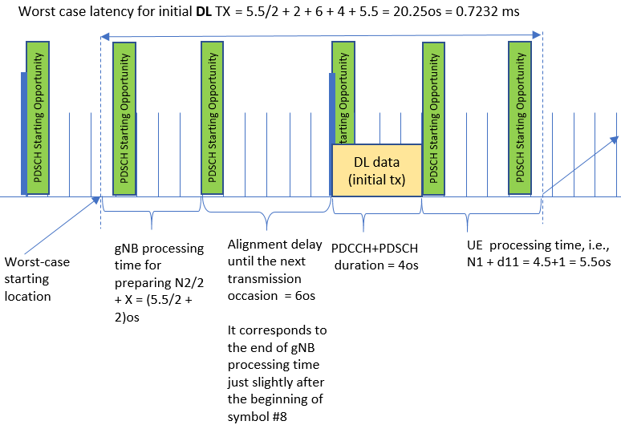

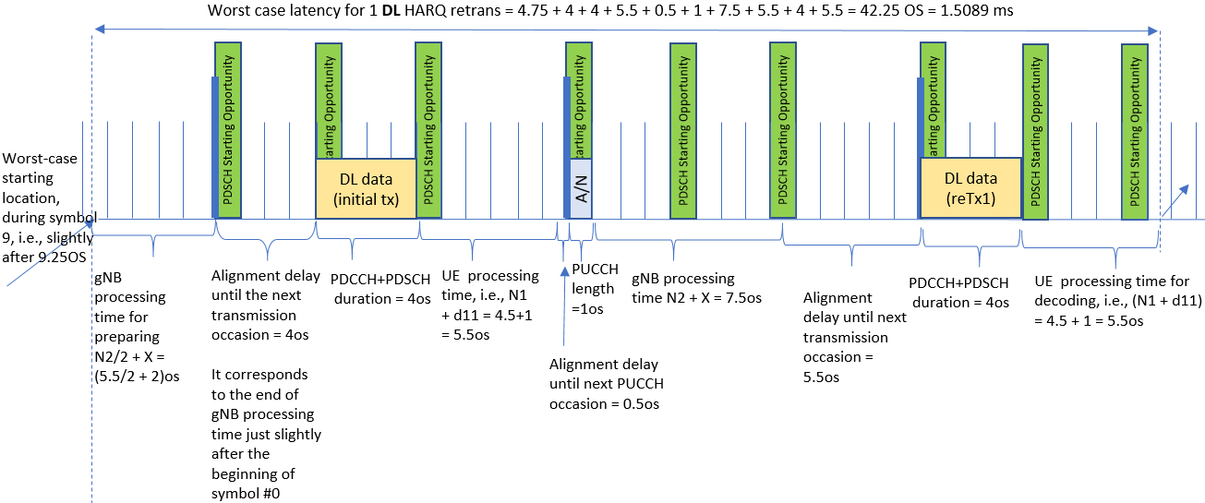

**Figure 1. DL transmission timeline and contributing components to the overall latency for one-shot TX (on top), and 1 reTX (on bottom)**