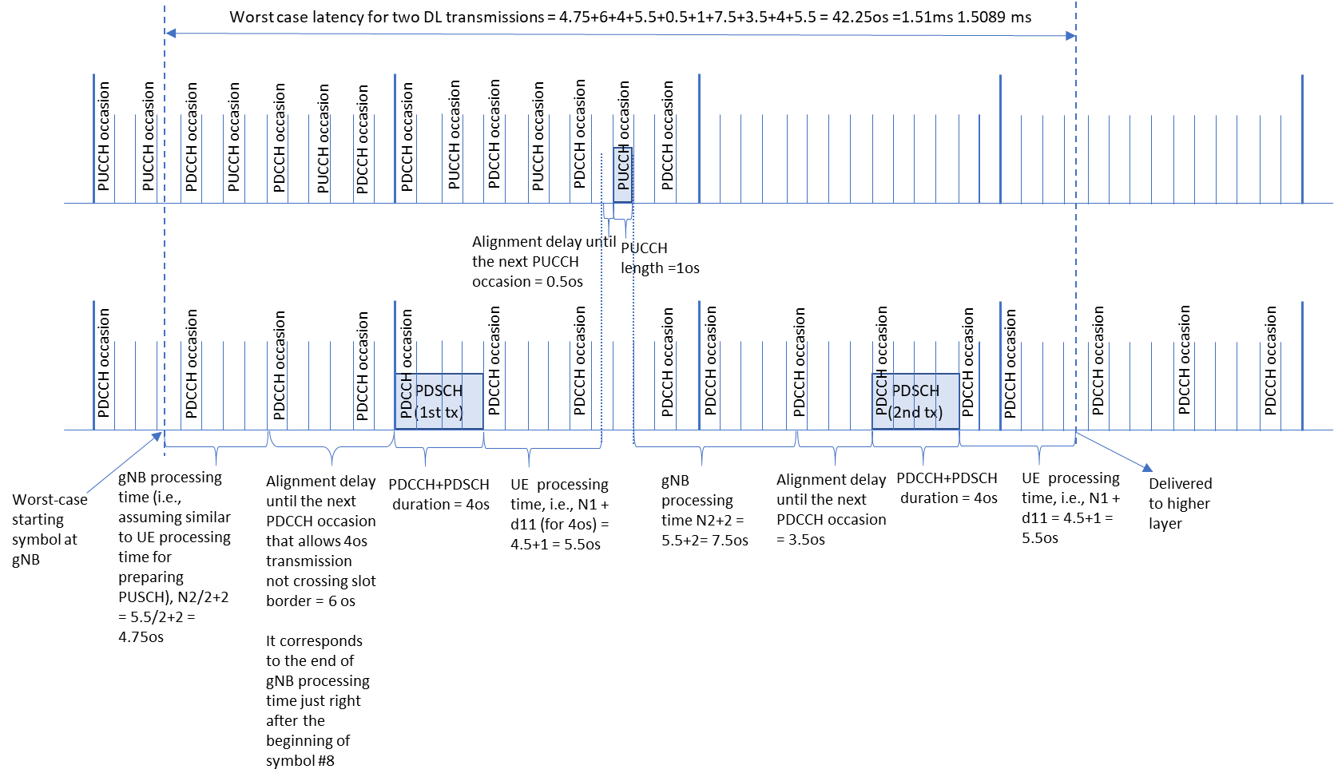

**Figure. A-1 Illustration of worst-case latency for Rel-15 UE capability, 2 transmissions of 4os-PDSCH, 30 kHz SCS, FDD**