Latency calculations Sharp

Methodology to identify the worst case latency
In our applied methodology;
DL:
Worst latency case for a certain PDCCH transmission occasion (A) within a slot is that PDCCH (and PDSCH) is ready after PDCCH transmission occasion available for PDCCH+PDSCH (B) just past. In this case, DL alignment time before the PDCCH equals the duration from (B) to (A). The worst latency case within a slot will be the largest latency case among all of the PDCCH transmission occasions within the slot.
SR-based UL:
Worst latency case for a certain SR transmission occasion (C) within a slot is that SR is ready after available SR transmission occasion (D) just past. In this case, UL alignment time before the SR equals the duration from (D) to (C) (2 symbols for FDD in this time). The worst latency case within a slot will be the largest latency case among all of the SR transmission occasions within the slot.
GF-based UL:
Worst latency case for a certain GF-PUSCH transmission occasion (E) within a slot is that PUSCH is ready after available GF-PUSCH transmission occasion (F) just past. In this case, UL alignment time before the SR equals the duration from starting symbol of (F) to starting symbols of (E). The worst latency case within a slot will be the largest latency case among all of the GF-PUSCH transmission occasions within the slot.

Note: In all case, we assume the timing of data arrival and the timing of decoding completion don’t need to align with symbol boundary. Therefore we use ceiling function on processing time except for initial and final processing.

Downlink latency analysis
Based on the assumption which was agreed on the e-mail discussion, the latency of downlink is composed of following components (as shown in figure 1):
(1) gNB Tx processing time: UE’s N2/2 + X (X = 2/4/8 symbols for SCS = 30/60/120kHz)
(2) DL alignment time: based on the PDCCH periodicity, available DL symbols and slot boundary. For the worst case, it equals the duration from available PDCCH transmission occasion just past
(3) DL transmission time: PDCCH+PDSCH duration with 1-symbol overlap (2/4/7 symbols)
(4) UE Rx processing time (and Tx processing time for NACK): N1 + d_1,1
Following is only for the case of 2 PDSCH transmissions
(5) UL alignment time: based on the PUCCH locations with available UL symbols
(6) A/N transmission time: 1 symbol
(7) gNB Rx+Tx processing time: UE’s N2 + X (X = 2/4/8 symbols for SCS = 30/60/120kHz)
(8) DL alignment time: depend on the timing of PDCCH transmission occasion, available DL symbols and slot boundary
(9) DL re-transmission time: same as (3)
(10) UE Rx processing time: N1 + d_1,1
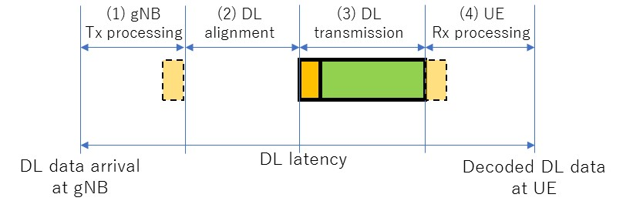
(a) single-shot PDSCH transmission
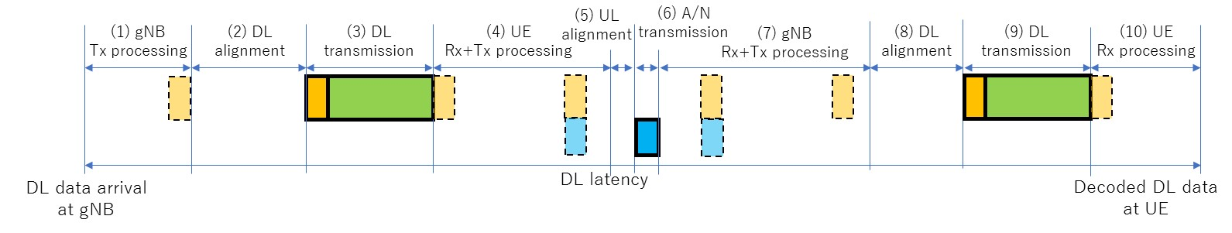
(b) two PDSCH transmissions
Figure 1: Processing timeline for DL latency

Example: Downlink latency for scenario 4 (SCS 30 kHz, N1=4.5OS, N2=5.5OS, PDSCH = 4OS, 7 MO)
single-shot transmission
PDCCH transmission symbol within a slot for worst case: #0
(1) 4.75OS + (2) 4OS + (3) 4OS + (4) 5.5OS = 18.25OS = 0.65ms
two transmissions
PDCCH transmission symbol within a slot for worst case: #0 (or #6)
(1) 4.75OS + (2) 4OS + (3) 4OS + (4) ceil(5.5)OS + (5) 0OS + (6) 1OS + (7) ceil(7.5)OS + (8) 1OS + (9) 4OS + (10) 5.5OS = 38.25OS = 1.37ms

Uplink latency analysis for SR based transmission
The latency of uplink with SR-based PUSCH transmission is composed of following components (as shown in figure 2):
(1) UL alignment time: based on the PUCCH locations with available UL symbols
(2) SR transmission time: 1 symbol
(3) gNB Rx+Tx processing time: UE’s N1
(4) DL alignment time: depend on the timing of PDCCH transmission occasion and available DL symbols
(5) PDCCH transmission time: 1 symbol
(6) UE Rx+Tx processing time: N2
(7) UL alignment time: depend on the slot boundary with available UL symbols
(8) UL transmission time: PUSCH duration (2/4/7 symbols)
(9) gNB Rx processing time: UE’s N1/2 + X (2/4/8 symbols for 30/60/120kHz SCS) (and additional UE’s N1/2 for Tx processing time for PDCCH for two transmissions case)
Following is only for the case of 2 PUSCH transmissions
(10) DL alignment time: depend on the timing of PDCCH transmission occasion and available DL symbols
(11) PDCCH transmission time: 1 symbol
(12) UE Rx+Tx processing time: N2
(13) UL alignment time: depend on the slot boundary and available UL symbols
(14) UL transmission time: same as (8)
(15) gNB Rx processing time: UE’s N1/2 + X (2/4/8 symbols for 30/60/120kHz SCS)
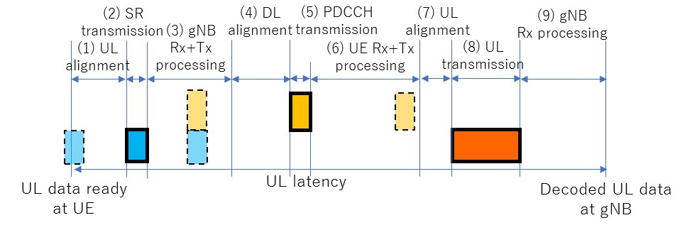
(a) single-shot PUSCH transmission
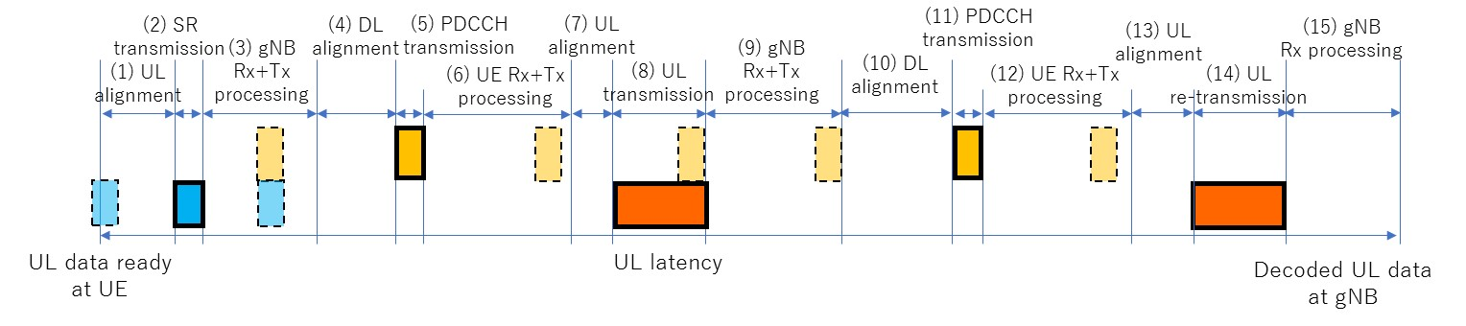
(b) two PUSCH transmissions
Figure 2: Processing timeline for UL latency with SR-based PUSCH transmission

Example: UL (SR-based) latency for scenario 5 (SCS 30 kHz, N1=4.5OS, N2=5.5OS, PUSCH = 7OS, 4 MO)
single-shot transmission
SR transmission symbol within a slot for worst case: #10 (PDCCH:#4, PUSCH:#0)
(1) 2OS + (2) 1OS + (3) ceil(4.5)OS + (4) 2OS + (5) 1OS + (6) ceil(5.5)OS + (7) 3OS + (8) 7OS
+ (9) 4.25OS = 31.25OS = 1.12ms
two transmissions
SR transmission symbol within a slot for worst case: #0 (1st PDCCH:#8, 1st PUSCH:#1, 2nd PDCCH#4, 2nd PUSCH:#0)
(1) 2OS + (2) 1OS + (3) ceil(4.5)OS + (4) 2OS + (5) 1OS + (6) ceil(5.5)OS + (7) 0OS + (8) 7OS
+ (9) ceil(6.5)OS + (10) 3OS + (11) 1OS + (12) ceil(5.5)OS +(13) 3OS + (14) 7OS + (15) 4.25OS
= 55.25OS = 1.97ms

Uplink latency analysis for CG based transmissions
The latency of uplink with grant-free PUSCH transmission is composed of following components (as shown in figure 3):
(1) UE Tx processing time: UE’s N2/2
(2) UL alignment time: depend on the timing of grant-free PUSCH transmission with available UL symbols
(3) UL transmission time: PUSCH duration (2/4/7 symbols)
(4) gNB Rx processing time: UE’s N1/2 + X (2/4/8 symbols for 30/60/120kHz SCS) (and additional UE’s N1/2 for Tx processing time for PDCCH for two transmissions case)
Following is only for the case of 2 PUSCH transmissions
(5) DL alignment time: depend on the timing of PDCCH transmission occasion and available DL symbols
(6) PDCCH transmission time: 1 symbol
(7) UE Rx+Tx processing time: N2
(8) UL alignment time: depend on the slot boundary and available UL symbols
(9) UL transmission time: same as (8)
(10) gNB Rx processing time: UE’s N1/2 + X (2/4/8 symbols for 30/60/120kHz SCS)
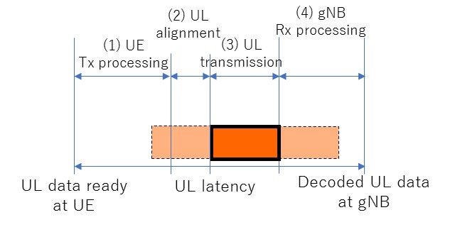
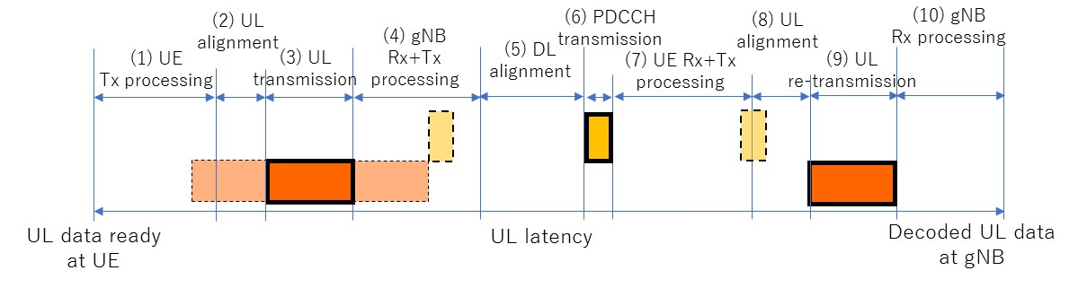
Figure 3: Processing timeline for grant-free PUSCH transmission

Example: UL (CG-based) latency for scenario 7 (SCS 60 kHz, N1=9OS, N2=11OS, PUSCH = 2OS, 4 MO)
single-shot transmission
GF-PUSCH transmission symbol within a slot for worst case: #0 (#2, #4, #6, #8, #10, #12)
(1) 5.5OS + (2) 2OS + (3) 2OS + (4) 8.5OS = 18OS = 0.32ms
two transmissions
GF-PUSCH transmission symbol within a slot for worst case: #0 (#4, #8) (PDCCH:#4, 2nd PUSCH:#2)
(1) 5.5OS + (2) 2OS + (3) 2OS + (4) 13OS + (5) 3OS + (6) 1OS + (7) 11OS + (8) 0OS+ (9) 2OS
+ (10) 8.5OS = 48OS = 0.86ms

