Latency calculations Huawei / HiSilicon

Methodology to identify the worst case latency
For the latency evaluation, the worst case latency shall be considered. Our applied methodology to obtain the worst case latency for a given configuration (SCS, MOs, PDSCH duration) is described below:
- The data from higher layers can arrive at the gNB at any symbol during the slot. The data arrival time is not necessarily aligned with the symbol boundary.
- Fourteen different data arrival times (one during each symbol in the slot) are assumed. Each of them triggers the start of one latency calculation. Thus, 14 different latency values L (i), i=0, 13 are obtained. The different data arrival times result in different latencies due to monitoring occasions and cross-slot scheduling constraints.
- The worst case latency is defined L=max{L(i)}, i=0,…,13

Downlink latency analysis

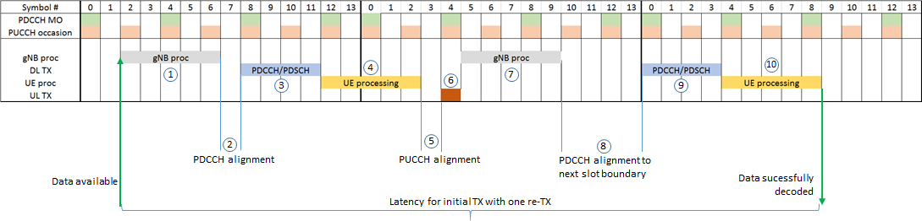
Figure 1 – Different contributors to the latency for downlink data transmission
An explanation of the different contributors to the overall latency is given below:
Nr. | Description | Explanation
1,7 | gNB processing | The time needed to prepare the transmission and to determine the scheduling decision.  For initial transmission (step 1), N2/2+X is assumed (X=2/4 for 30/60 kHz SCS)  For retransmission (step 7), N2+X is assumed (X=2/4 for 30/60 kHz SCS)
2 | Transmission alignment: | The UE is monitoring the PDCCH only on pre-defined symbols. When the gNB has made its scheduling decision it has to wait until the next PDCCH monitoring occasion (MO) in order to transmit the PDCCH carrying the DL assignment. The granularity of the PDCCH monitoring is a result from a trade-off between PDCCH reliability (which maximum aggregation level shall be monitored in each monitoring instance) and the desired latency (how many PDCCH monitoring instances can be configured within one slot).  Two cases are evaluated:  - 7 MOs/slot at OS #0, #2, #4, #6, #8, #10 and #12  - 4 MOs/slot at OS #0, #4, #8 and #12
3 | PDCCH/PDSCH transmission duration | The time it takes to transmit the control channel and the data channel. The PDCCH is only expected to be transmitted at a MO. In general the PDSCH can start at any symbol but not earlier than the CORESET which is containing the scheduling PDCCH. The PDSCH can only have durations of 2, 4 and 7 OS and is allowed to overlap on the same symbols with the PDCCH.  In the evaluations PDSCH durations of 2, 4 and 7 symbols are assumed. It is assumed further that the PDCCH duration is one symbol and that PDCCH and PDSCH overlap with 1OS.
4, 10 | UE PDSCH Processing | Time from the end of the PDSCH reception until the earliest possible time when HARQ-A/N can be transmitted. If the PDSCH decoding has been successful, the UE can sent the data to higher layers. If not, a retransmission has to be initiated. The maximum allowed PDSCH decoding time is specified in 38.214 [2] in terms of OFDM symbols. The PDSCH processing time is N1 + d1_1. For the aggressive UE cap#2 the N1 value is {4.5, 9} OFDM symbols for {30, 60} kHz SCS. When there is an overlap of one symbol between the PDSCH and the PDCCH, and the PDSCH length is 2 or 4 OFDM symbols, d1_1=1. For PDSCH length of 7 OFDM symbols, d1_1=0.  Thus, in the evaluation, following values are used:  - 2OS PDSCH: N1+1  - 4OS PDSCH: N1+1  - 7OS: N1
5 | Uplink transmission alignment | The time between when HARQ feedback is ready to be transmitted until the next PUCCH is available to send the HARQ feedback.  It is assumed that the PUCCH can be transmitted on every even symbol index, i.e. at OS #0, #2, #4, #6, #8, #10 and #12
6 | PUCCH duration | The time duration of the PUCCH carrying the A/N. If the last PUCCH was carrying an NACK, the gNB has to successfully decode this message and initiate a retransmission of the TB, where the above processing steps are repeated until the maximum number of retransmissions has been reached or the TB has been decoded correctly.  In the evaluations, only one re-TX is assumed and the PUCCH duration is assumed to have a length of 1OS.
8 | PDCCH alignment to the next slot boundary | If the gNB has to send a re-TX, it can do it at the next MO. A PDSCH is not allowed to be scheduled across a slot boundary. If the PDSCH duration is longer than what there are symbols left in the current slot, the gNB has to delay the PDSCH transmission at least until the start of the next slot. This increases the worst case latency

Example: Downlink latency
Table 1 - SCS 30 kHz, N1=4.5OS, N2=5.5OS, OS, PDSCH = 4OS, 7 MO, data arrives 0.3 OS into the ongoing symbol
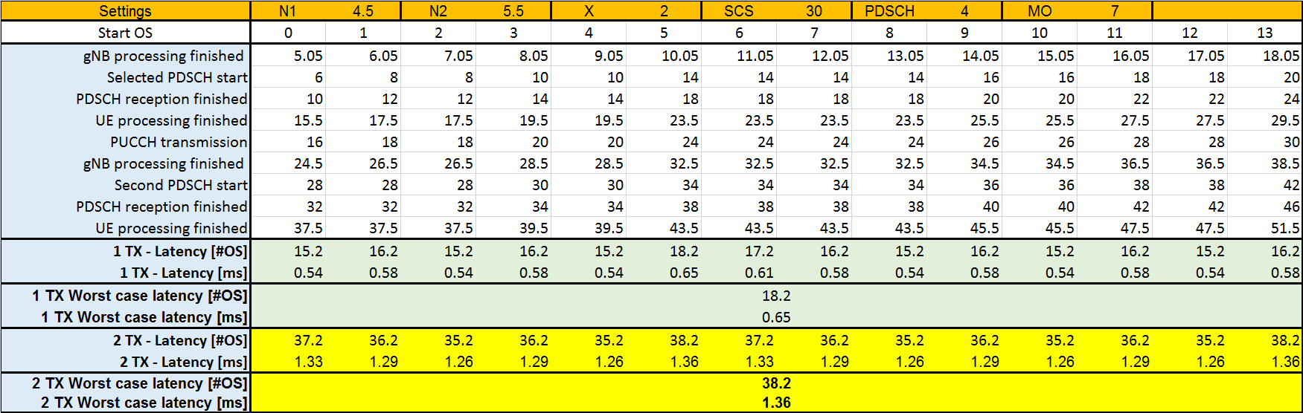

Uplink latency analysis for SR based transmission
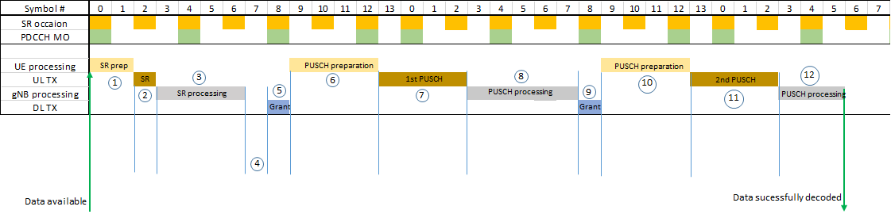
Figure 2 - Different contributors to the PUSCH latency, SR based transmission
An explanation of the different contributors to the overall latency is given below.
Nr. | Description | Explanation
1 | UE SR processing and SR alignment | The time needed to prepare transmission of the SR and to determine when it can be transmitted including the alignment to the next SR occasion.  The gap between two consecutive SR occasions is two symbols. This time is assumed to be used for the UE processing alignment.
2 | SR duration | The duration of the SR transmitted on PUCCH.  1OS is assumed.
3 | gNB SR Processing | The time it takes to process the SR once it has been completely received, decide on a PUSCH grant, schedule and encode it. Depending on the implementation and the load in the cell, this time may vary significantly.  N1 is assumed in the evaluations.
4 | PDCCH Transmission alignment | The UE is monitoring the PDCCH only on pre-defined symbols. When the gNB has made its scheduling decision it has to wait until the next PDCCH transmission occasion in order to transmit the grant. It is then further assumed that the grant can be transmitted, i.e. that no PDCCH blocking occurs.  Two cases are evaluated:  - 7 MOs/slot at OS #0, #2, #4, #6, #8, #10 and #12  - 4 MOs/slot at OS #0, #4, #8 and #12
5 | PDCCH duration | The time it takes to transmit the PDCCH carrying the UL grant.  1OS is assumed.
6 | PUSCH preparation | The time from the end of the PDCCH reception at the UE until the earliest possible time when the PUSCH can be transmitted. The maximum allowed PUSCH preparation time is specified in 38.214 [2] in terms of OFDM symbols.  It is assumed that the first PUSCH symbol only contains DMRS, therefore the PUSCH preparation time is equal to N2.
7, 11 | PUSCH duration | The time duration of the PUSCH.  In the evaluation PUSCH durations of 2, 4 and 7 symbols are assumed.
8, 12 | gNB PUSCH Processing | The time it takes for the gNB to process the PUSCH once it has been received and in case of an error, to schedule a retransmission grant. Hence, this processing time is split into two components, the PUSCH decoding.  For PUSCH-to-PDCCH (step 8) a duration of N1+X is assumed, where N1 is according to 38.214 and X is 2 symbols for SCS 30 kHz and 4 symbols for SCS 60 kHz.  For the final PUSCH reception (step 12), no PDCCH transmission is required. The assumed processing time is N1/2+X.

Example: UL (SR-based) latency calculation
Table 2 - SCS 30 kHz, N1=4.5OS, N2=5.5OS, PUSCH = 7OS, 4 MO
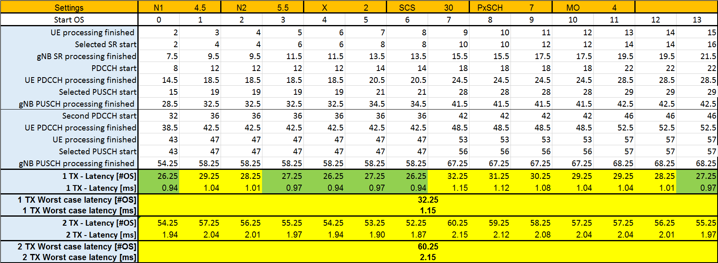

Uplink latency analysis for CG based transmissions
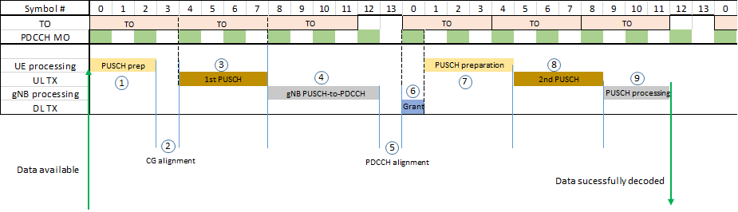
Figure 3 - Different contributors to the PUSCH latency, SR based transmission
An explanation of the different contributors to the overall latency is given below.
Nr | Description | Explanation
1, 7 | PUSCH preparation | The time needed to prepare PUSCH.  In step 1, for configured grant N2/2 is assumed.  In step 7, for scheduled grant N2 is assumed
2 | CG alignment | The alignment to the next TO for the configured grant. Following configurations are assumed:  - For 2OS PUSCH, TOs start at OS #0, #2, #4, #6, #8, #10 and #12  - For 4OS PUSCH, TOs start at OS #0, #4 and #8  - For 7OS PUSCH, TOs start at OS #0 and #7
3, 8 | PUSCH duration | The time duration of the PUSCH.  In the evaluation PUSCH durations of 2, 4 and 7 symbols are assumed.
4,9 | gNB processing | The time it takes for the gNB to process the PUSCH once it has been received and in case of an error, to schedule a retransmission grant. Hence, this processing time is split into two components, the PUSCH decoding.  For PUSCH-to-PDCCH (step 4) a duration of N1+X is assumed, where N1 is according to 38.214 and X is 2 symbols for SCS 30 kHz and 4 symbols for SCS 60 kHz.  For the final PUSCH reception (step 12), no PDCCH transmission is required. The assumed processing time is N1/2+X.
5 | PDCCH alignment | The UE is monitoring the PDCCH only on pre-defined symbols. When the gNB has made its scheduling decision it has to wait until the next PDCCH transmission occasion in order to transmit the grant. It is then further assumed that the grant can be transmitted, i.e. that no PDCCH blocking occurs.  Two cases are evaluated:  - 7 MOs/slot at OS #0, #2, #4, #6, #8, #10 and #12  - 4 MOs/slot at OS #0, #4, #8 and #12
6 | PDCCH transmission | The PDCCH carrying the UL grant.  1OS duration is assumed.

Example: UL (CG-based) latency calculation
Table 3 SCS 60 kHz, N1=9OS, N2=11OS, PUSCH = 2OS, 4 MO
