3GPP SA WG3-LI (S3-LI) # 03/01

19 – 21 February 2003. Paris, France
AQSACOM has the great pleasure of inviting you to the 3GPP SA WG3-LI (S3-LI) # 03/01 meeting held in Paris, France. The meeting will start on Wednesday 19th February 2003 and will end on Friday 21st February 2003.
The meeting will take place at Hotel Plazza Bastille in the center of Paris near Opéra Bastille.
We have already booked 25 single rooms at the same hotel at a special price of 105 €/night, including breakfast.
You will find hereunder detailed information about the meeting, the hotel and how to get there.
Planning details with registration may be found at the 3GPP web reference http://webapp.etsi.org/MeetingCalendar/MeetingDetails.asp?mid=22777
AQSACOM will organize a dinner on February 20th in a restaurant in Paris , where you can test French Cooking.
Refreshments and lunch arrangements will be offered during the meeting.
Please fill in the enclosed hotel registration form and send it by mail to josette.mahoue@aqsacom.com or jeanfrancois.zell@aqsacom.com or fax it to AQSACOM +33 1 69 29 84 01
Plazza Hotel Address:
74, rue Amelot
75 011 Paris
Phone:
+33 (0)1 40 21 20 00
Fax:
+33 (0)1 47 00 82 40
Station: Sébastien Froissart
Please note that the hotel has set the reservation deadline till January 10th 2003. After the due date the 105€ price is no longer guaranted.
If you have further questions or preferences regarding the accommodation please contact:
Josette mahoue  Fixed: +33 1 69 29 84 00  Fax. +33 1 69 29 84 01  josette.mahoue@aqsacom.com | jean-françois zell  Fixed: +33 1 69 29 36 01  Fax. +33 1 69 29 84 01  jeanfrancois.zell@aqsacom.com
Kind regards,
Jean-François ZELL
Hotel information and map:
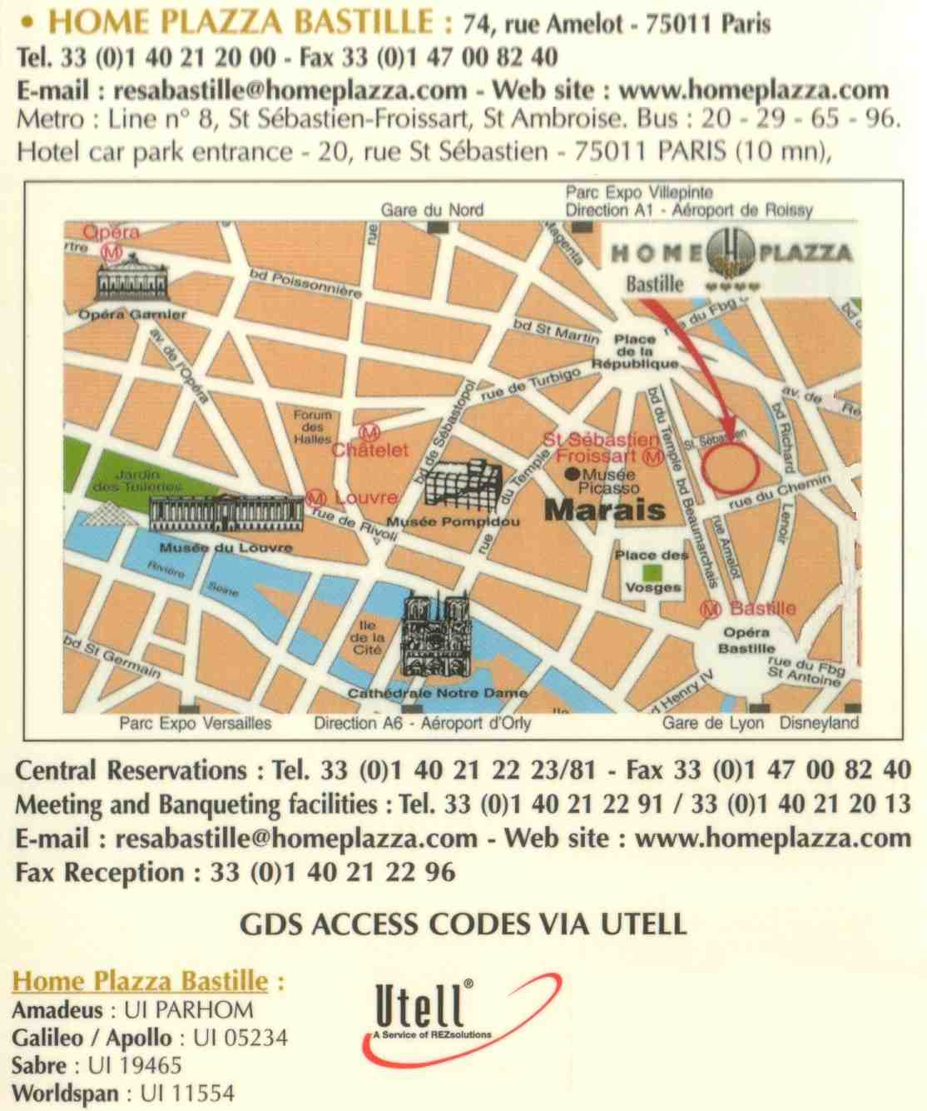
Airport information:
Roissy-Charles De Gaulle airport is the major airport in Paris. You can find taxi to get to Paris (around 40 €).
If you want to use public transportation, you can follow "Paris By train" indications. In Terminal 2 (CDG2) and Terminal 3 (CDG3), there is railway station. From Terminal 1 (CDG1), you need to take a bus shuttle (number 2) till Terminal 3 (CDG3) (first stop : "TGV gare" and "RER gare"). The best solution is to choose a direct train (RER B) to "Paris Gare du Nord" (around 10 €).
To get to HOME PLAZZA BASTILLE , you must leave the RER B at "Gare du Nord", take a subway (line #5, direction "Place d'Italie") till "Republique" and then take the subway line #8 (direction "Creteil Prefecture") till "St-Sébastien Froissart".
Orly airport is the second airport in Paris. You can find taxi to get to Paris (around 35 €).
If you want to use public transport, you must take "Orly Val" shuttle till Anthony and then the RER B (direction "Gare du Nord") till "Denfert Rochereau". You have to change and take the subway line # 6 (direction Nation) till Daumesnil and then take the line # 8 (direction Balard) till St-Sébastien Froissart.
Detailed map
