10 K FOR 10 YEARS OF 3GPP
CHARITY ROAD RUN
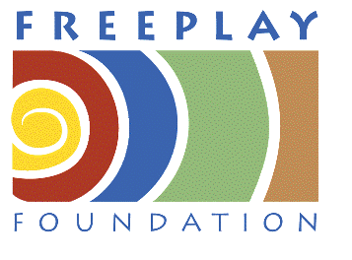
www.freeplayfoundation.org

Runners will lap the Parthenon in Athens to complete a 10KM run in celebration of 10 years of work on the standards for 3G mobile.

1st run will be on Thursday 4 December, 2008 at 07:30 AM
2nd run will be on Tuesday 9 December, 2008 at 07:30 AM

A scenic course through the beautiful Athens

ENTRY FEES 15€ per person per run
Only Euros will be accepted.
-------------------------------------------------------------------------------
Run on 4th December   Run on 9th December 

  2Km   5Km   10 Km

First name .........................………………. Surname………….........................………..SEX;M/F....….
FULL ADDRESS....................................................................................…………………….
.................................................................................................................………………………

TELEPHONE NUMBER.....................…………………………….

I declare that I will abide by the laws and rules of the Greek Authorities. I am aged 17 0r over and I accept that the organizers will not be liable for any loss, damage, action claim or expenses, which may arise in consequence of my participation in this event. I declare that I will not complete this race unless I am in good health on the day and that, in any event I will only compete at my own risk.

SIGNATURE..................................................................... DATE..........................

